Google Cloud translation settings and instructions

1. Activate Google Cloud account:
2. Try it for free and get $400 free trial credit

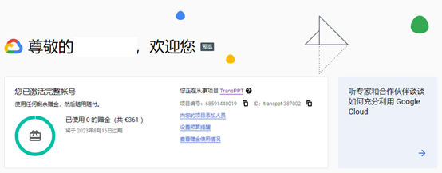

1. Create a project, remember this “project ID”

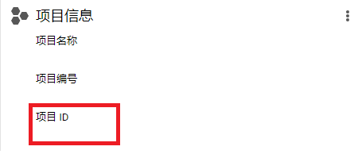

1. Open Google translate service

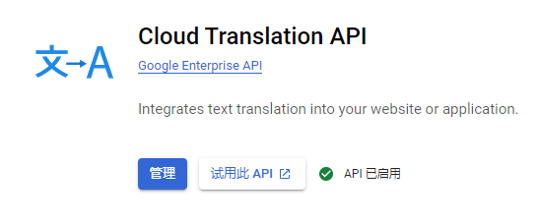

1. create credentials

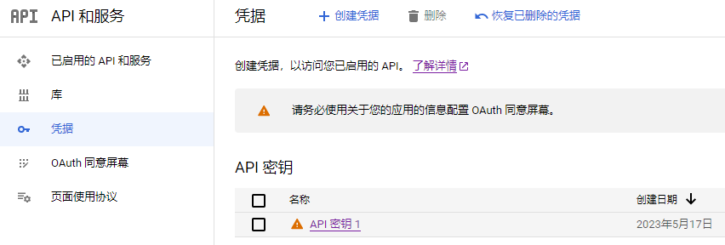

1. Credentials to create a service account

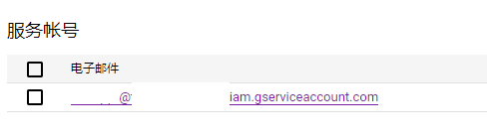

1. Manage the key in the service account, add the key, JSON format, save to the “key path”

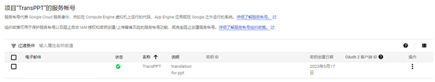

1. set GOOGLE_APPLICATION_CREDENTIALS=D:\transPPT\transppt-387005-11e060675fe8.json Set Google “key path”. NOTE: This key cannot be shared and is recommended to be updated regularly
2. Set the project ID (parent, model) in the code

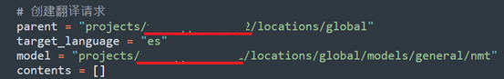

1. Install python and pip install related code packages (use chatGPT to ask)
2. When an error occurs, open the comment # print(run.text) to locate the error location
3. D:\transPPT>python transppt3.py
4. Note: If there is a “combination” in the current code PPT, the internal text may not be translated. If this problem occurs, first “ungroup” and then translate